1 2
MSP
On Your Home Computer
Or
Smart Phone

In your HOME COMPUTER you must go to:

https://www.rotundasoftware.com/ministry/stpiuscda

3 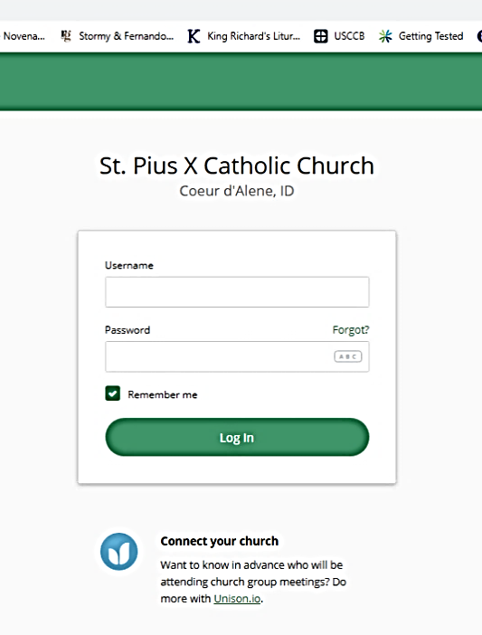
Get your username and password from me. Once you use this password, the computer may want you to change your password. You MUST REMEMBER your password after this. If St. Pius X Catholic Church is not there and the computer should ask you for “Your Organization,” enter “stpiuscda.”

4 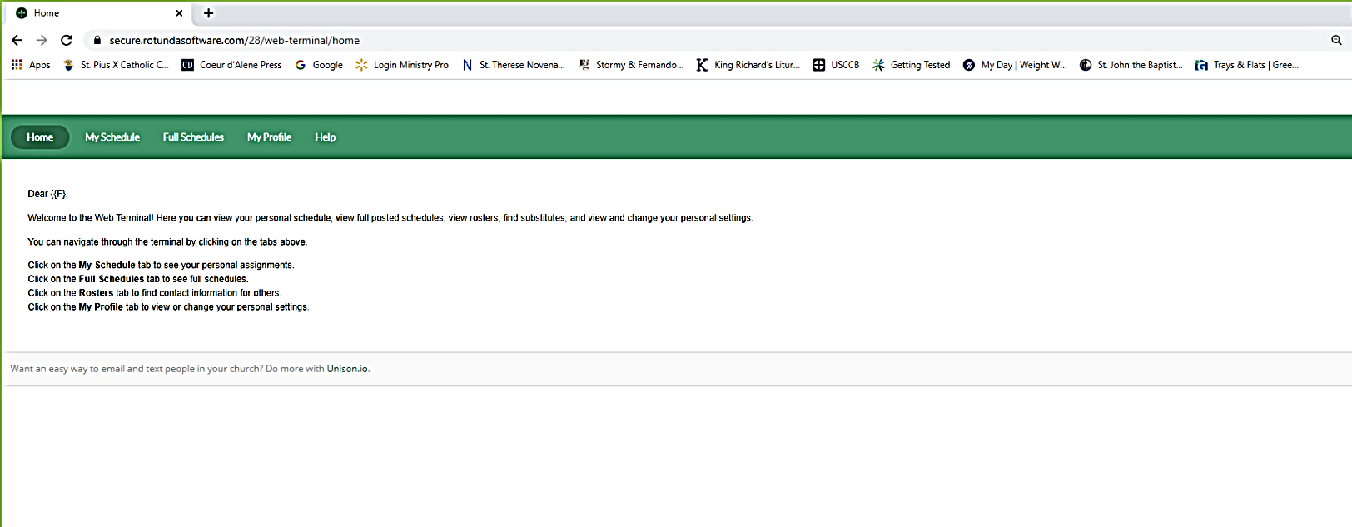
Gives you: My Schedule, Full Schedule, and My Profile.
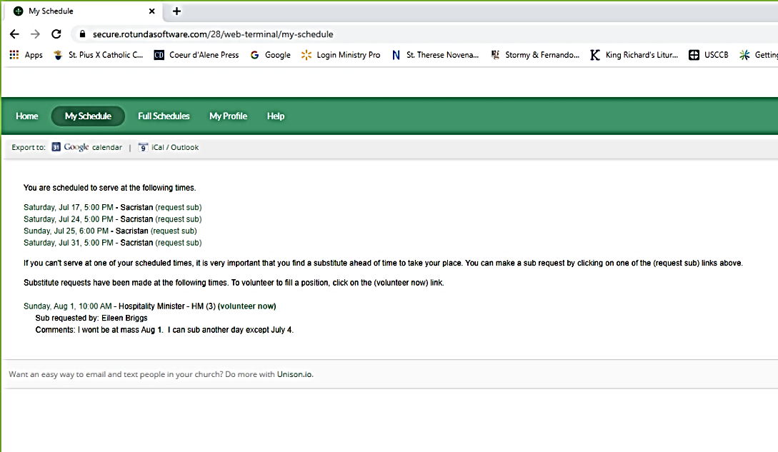
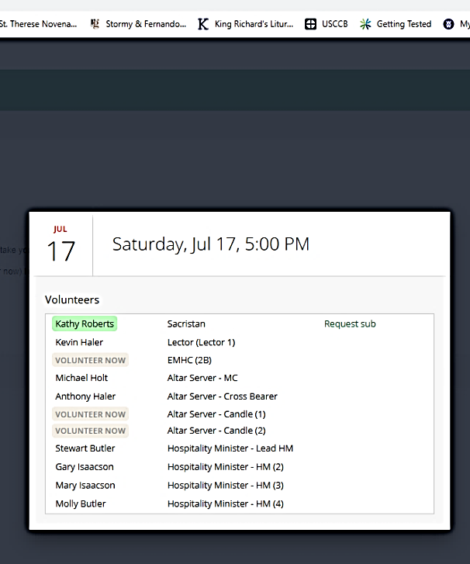
My Schedule: You can ask for a sub here or click onto one of the dates, to give you all those serving. Also, gives you the opportunity to ask for a sub again.

6
5
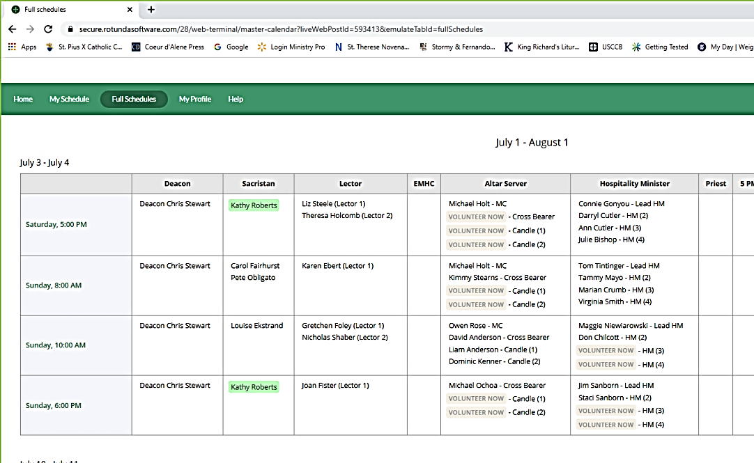
7
&
8
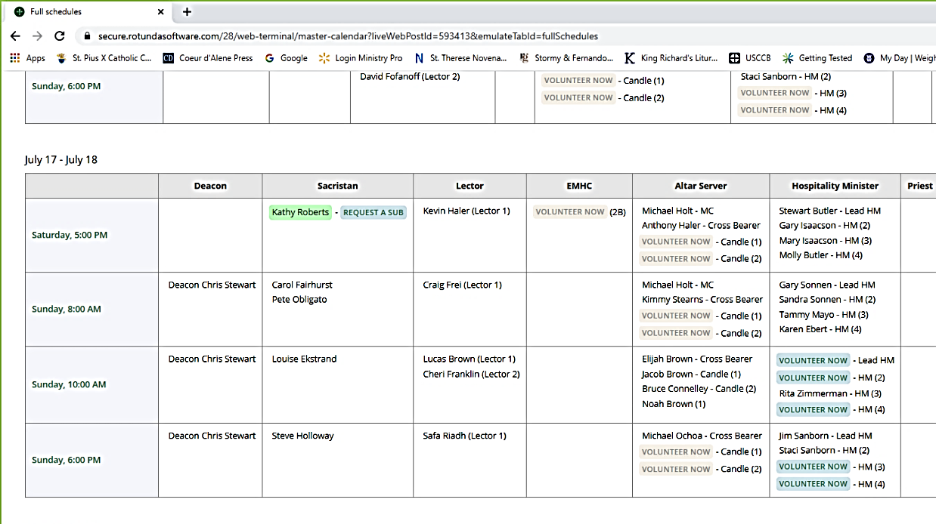
If you click onto “Full Schedules,” and scroll down, it will list all the dates and Masses that are scheduled. It will also list who is scheduled for each position as well as positions that are have not be filled. By clicking onto a position that says “volunteer now,” you can volunteer to do that position. You can also ask for a sub for yourself.

9 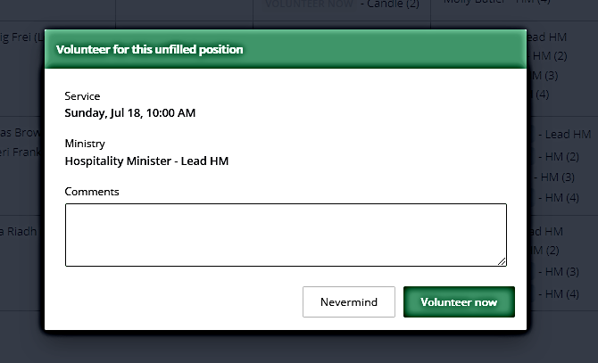
By clicking: Volunteer now, you can add any comments you want or leave blank.

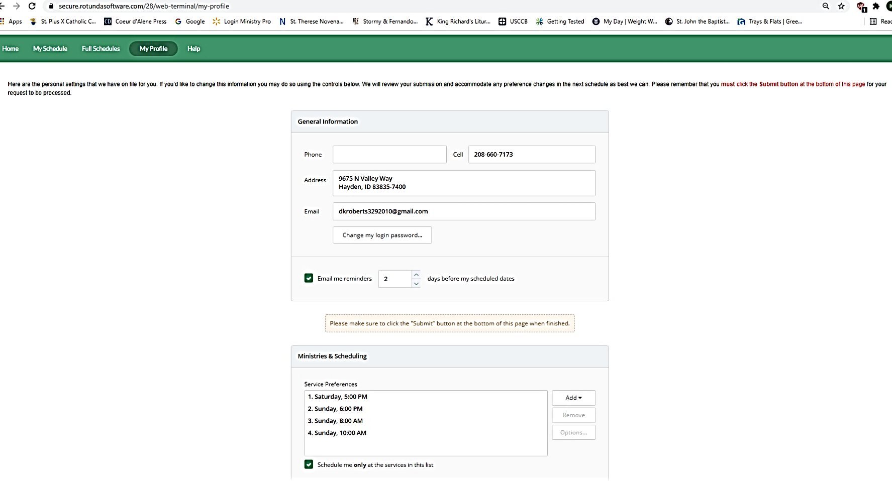
My Profile: Here you can change your address, phone number, email address, and also your password. Scroll down, can change Mass Preference times-add or remove.

10
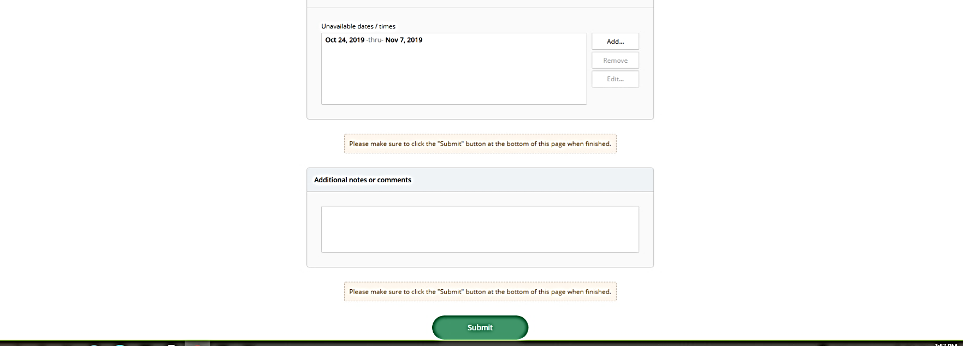
Scroll down more and you can enter the dates that you are unavailable. This is important. Once you have entered these dates, the computer will not schedule you for this time. Click onto “Add.”

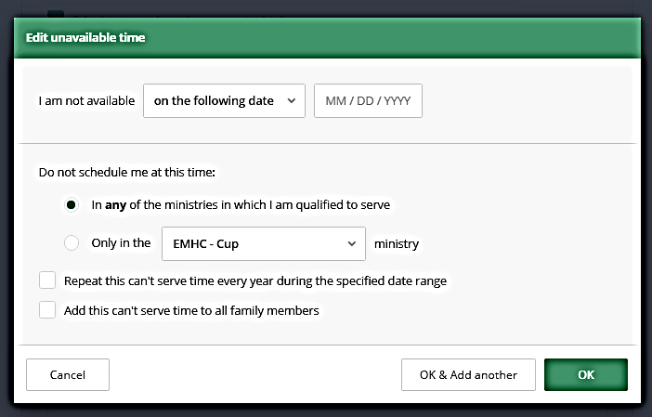
Once you have clicked onto Add for Unavailable dates/time, this box will appear. Always have the line “in any of the ministries in which I am qualified to serve” marked. This is especially important if you serve in more than one ministry.

11

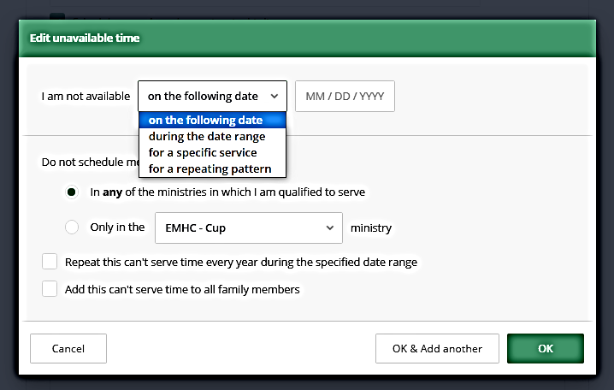
12
Can click on a single date or for a particular period of time.

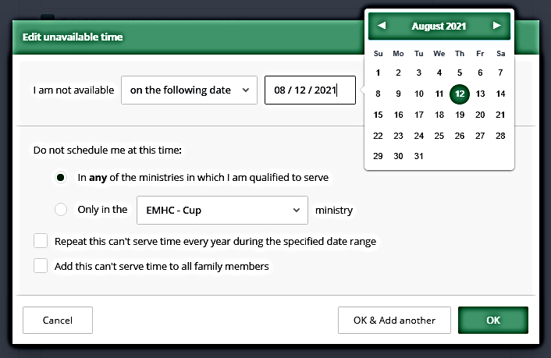
13
When entering a date, the date cannot be during a time where the schedule has already been made out. Dates must be entered before the schedule is made. Can enter dates as far ahead as next summer or even next year if you know you are going to be gone or busy. If you entered “during a date range,” you will get beginning and ending calendars.

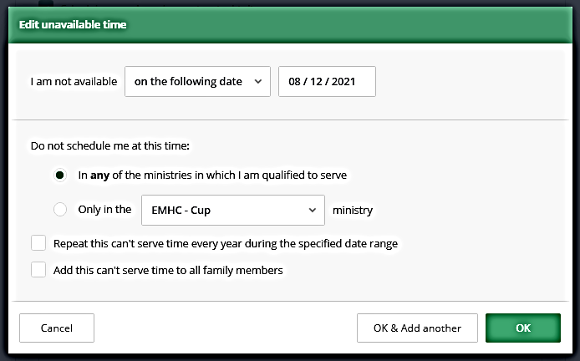
Date is there, click OK. Can add additional dates by clicking OK & Add another.
14
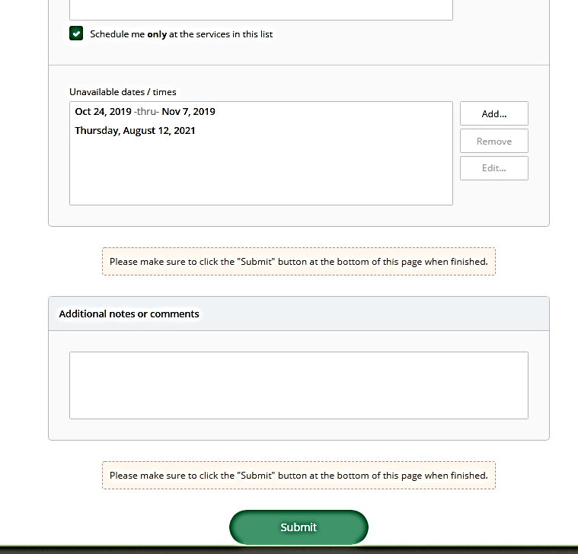
15
Before anything is final after you have made changes or added information, you must always click “Submit” at the bottom of the page.

See the date(s) you have entered here. You can always edit these by clicking onto the date and add or remove.

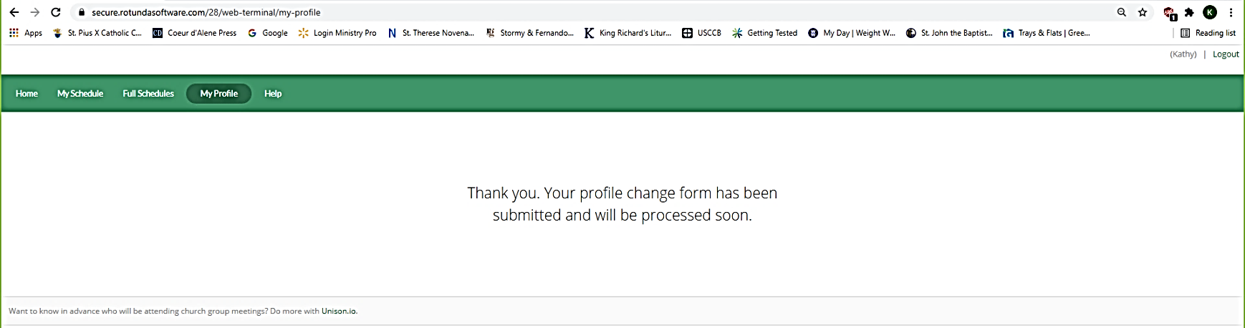
16

If there are other members of your family using MSP and have the same email address, your names will be listed here and you can make changes to the other members without logging in and out. If you “X” out and forgot to logout, you will be probably be logged out. It is very important to remember your password.

17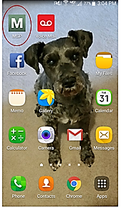 18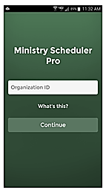
Enter “stpiuscda” for “Organization ID.” “stpiuscda” should pop up automatically when you go into this app in the future. Click “Continue.”

MSP on Your Smart Phone: To download this app, go to your app store (such as “Play Store”) & enter “Ministry Scheduler Pro.” This icon will come up. Download it.

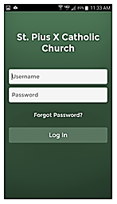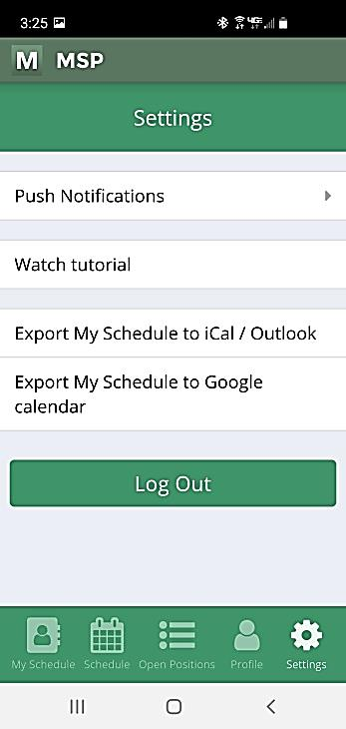
At the bottom, you have the option to view any of these things. “My Schedule” “Full Schedule” “Open Position” “My Profile” and you are in “Settings”. You may “Log Out” here, but you must remember your username and password to get back in. If you forget one of these, contact me & it can be reset. No need to logout using smart phone.

20
19
To get your “Username” & “Password,” email me at: “dkroberts3292010@gmail.com & I will email it to you. Must remember your username & password.

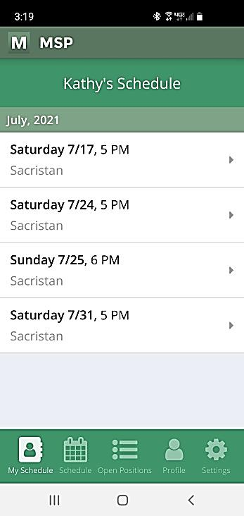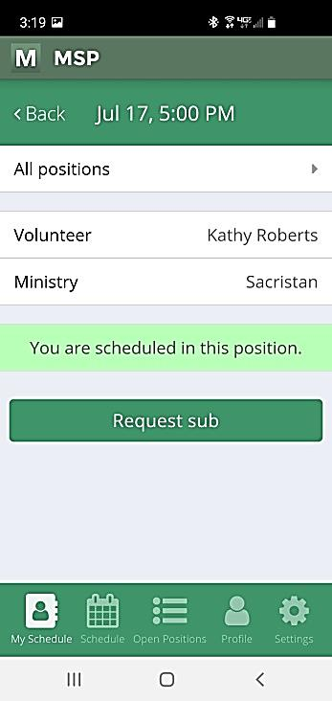
22
If you click “All Positions,” all positions & names will appear. If you need a substitute for this day, then click “Request Sub” & follow through. This is the only place where you can “Request Sub” on the phone app.

My Schedule
Scroll down to find date you wish to view and click.

21

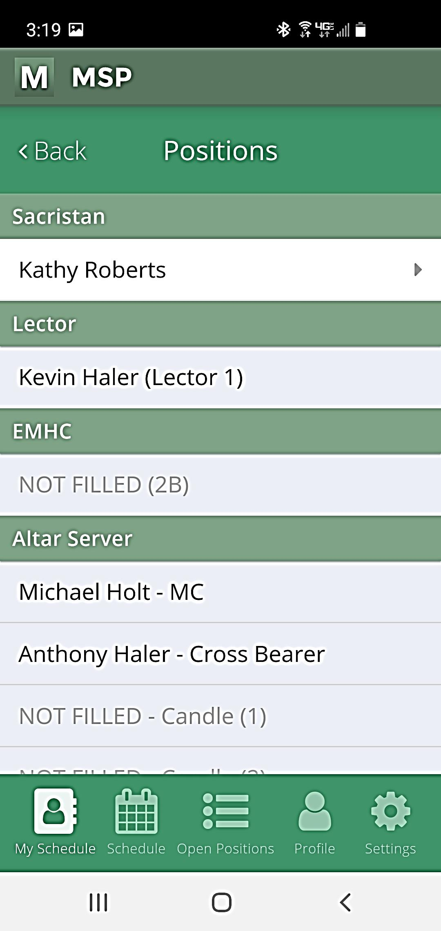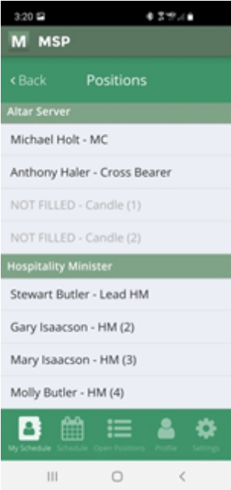
23

If you scroll down, you could see all the volunteers & positions.

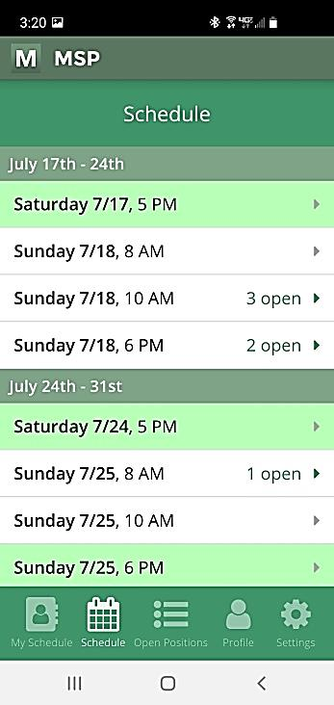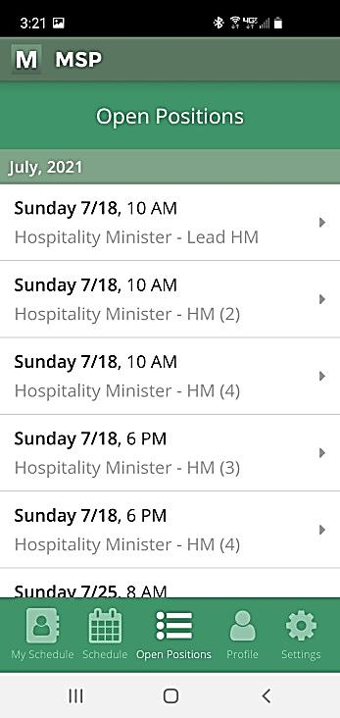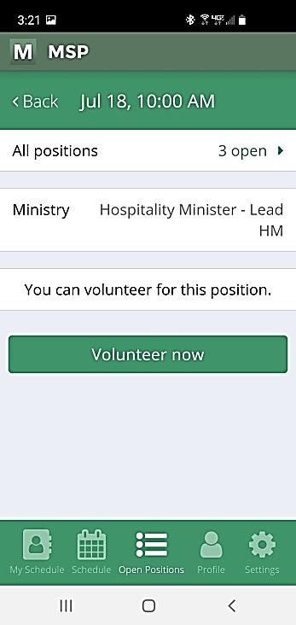
25
24
Full Schedule: Scroll down & click onto day you need information. Can view all Masses & who is scheduled for each position. Works in the same way as My Schedule.

Open Positions: Will only list those positions that you are legible to serve. Click onto the which Sunday Service, and then again choose what position, etc you want to volunteer for. You may volunteer here.

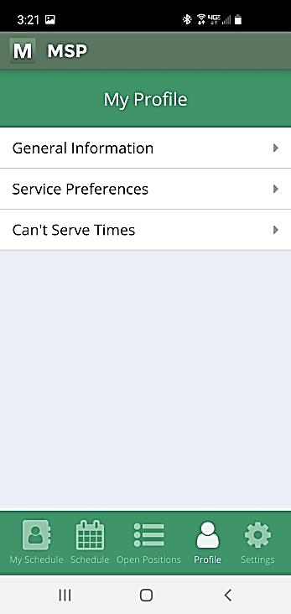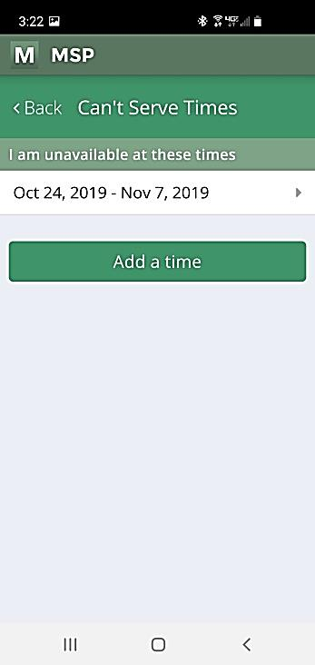
My Profile: General Information gives your phone number, email, & address. These can be updated by you. Service Preferences gives you the Mass times you want to serve. You can changes these.
27
26
My Profile: this is where you can go to request days off not to serve. Click onto “Can’t Serve Times.” This request must be made before the schedule is created. You may request days off far in advance if you know you are going to be gone. Once the schedule has been created, then you will need to request a substitute in “My Schedule.”

29
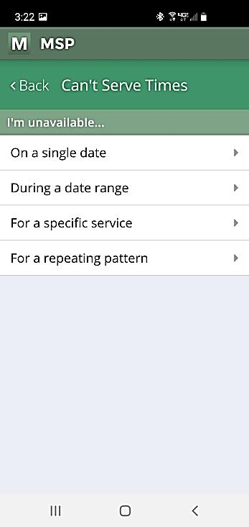
Click onto one of these options. Most likely a single date or date range for more than one week.

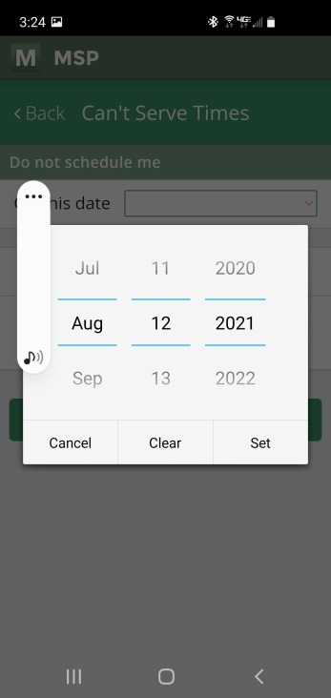
You must scroll up or down for the month, day, & year, then click Set. If you do a date range, you will get a beginning & ending calendar.

On this date
31
28

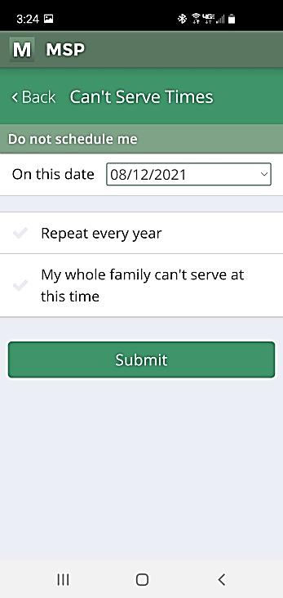
You may view your Assignments
- In MSP in “My Schedule” or Full Schedule.”
- By going into our Parish Website:
  - www.stpiuscda.org.
  - Click onto Mass
  - Click onto Ministry Scheduler Software
  - Click for Online Ministry Schedule
- The Schedule is printed in the Narthax.
Note: Schedule is made out on the 20th of each month.
30
Click Submit . Must click submit or your date will not be saved. You can then go through the same process & submit other dates.
The computer will not schedule you for this date(s).

Note: You do not need to log out on your phone.

If you have any questions, need help, etc. please contact me, Kathy Roberts at 208-660-7173 or email me at dkroberts3292010@gmail.com

